LAB 3: ARRAY IMPLEMENTATION IN JAVA

Name: Shreyas Sawant Div: D7A Roll No.: 55

1-D Array

Q1. Write a program   
i) To print the array in reverse order

CODE:

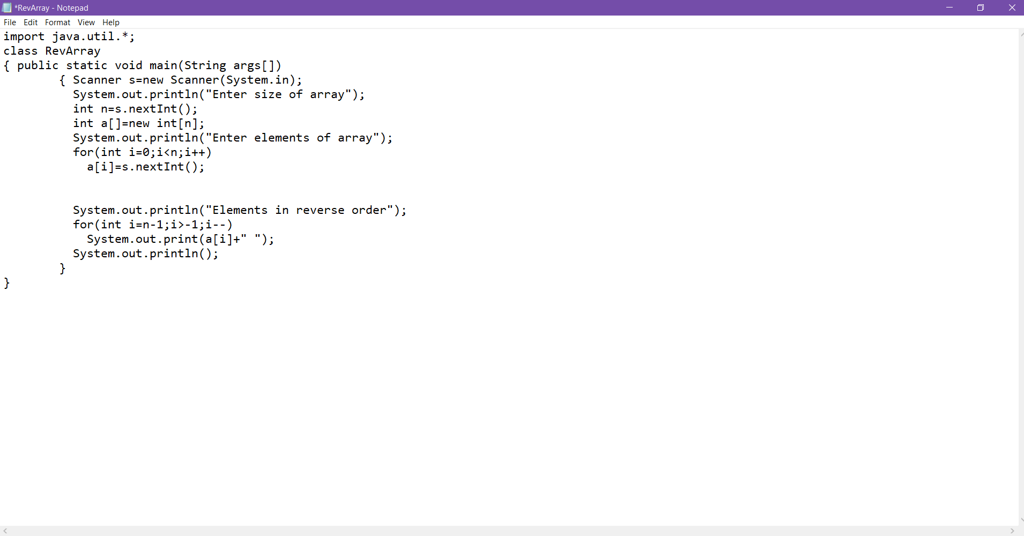

OUTPUT:

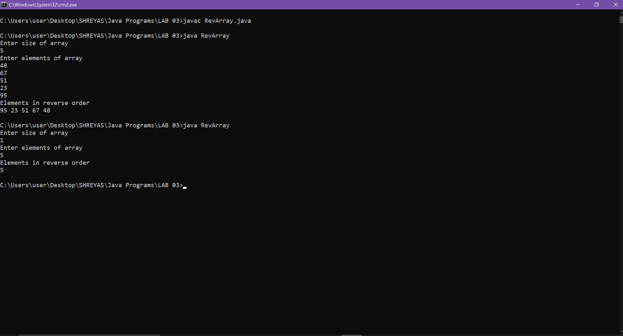

ii) To reverse the array

CODE:

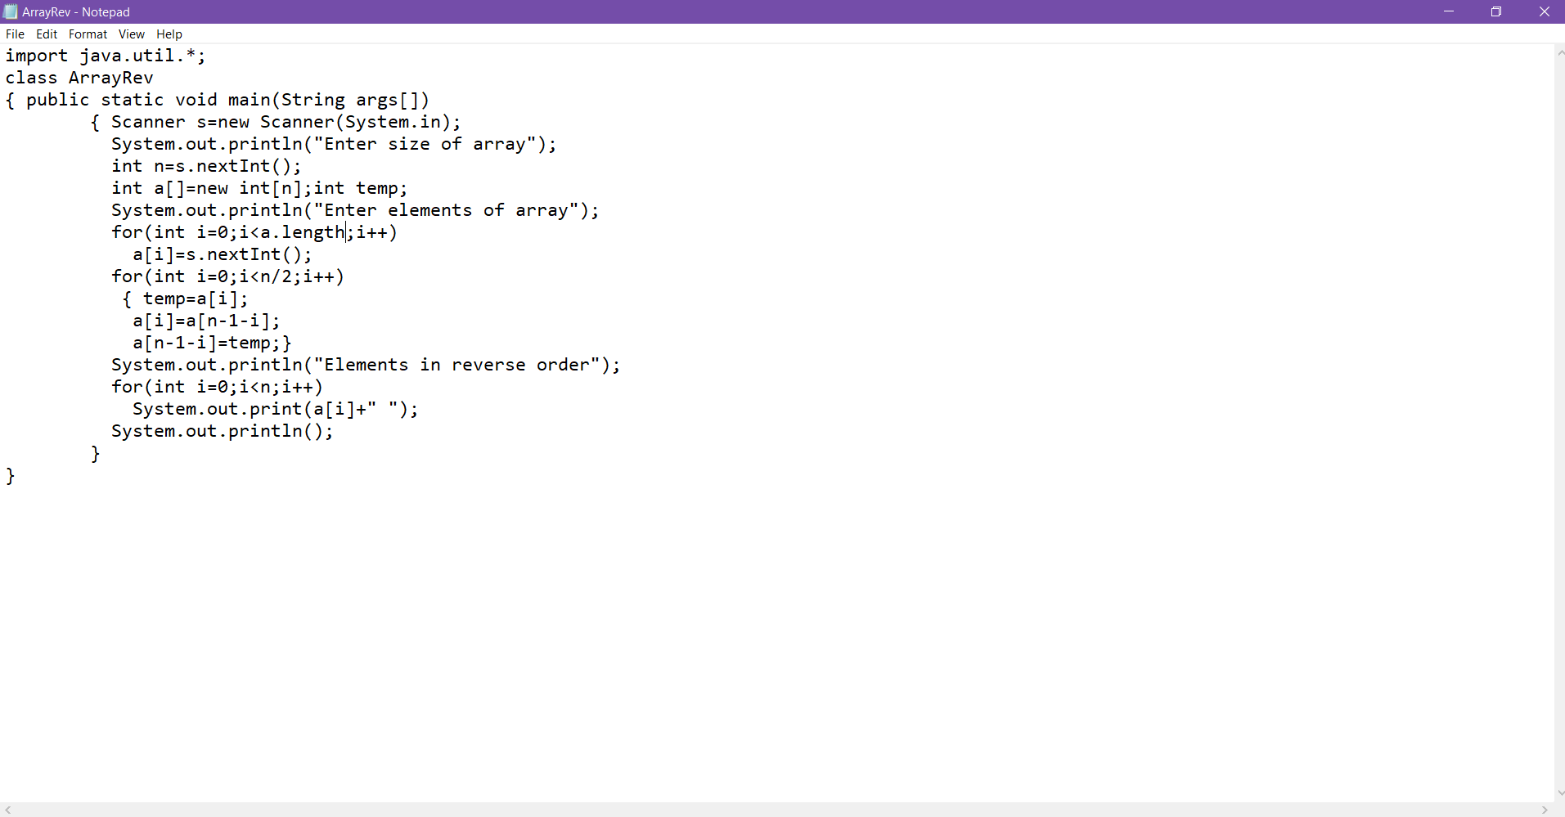

OUTPUT:

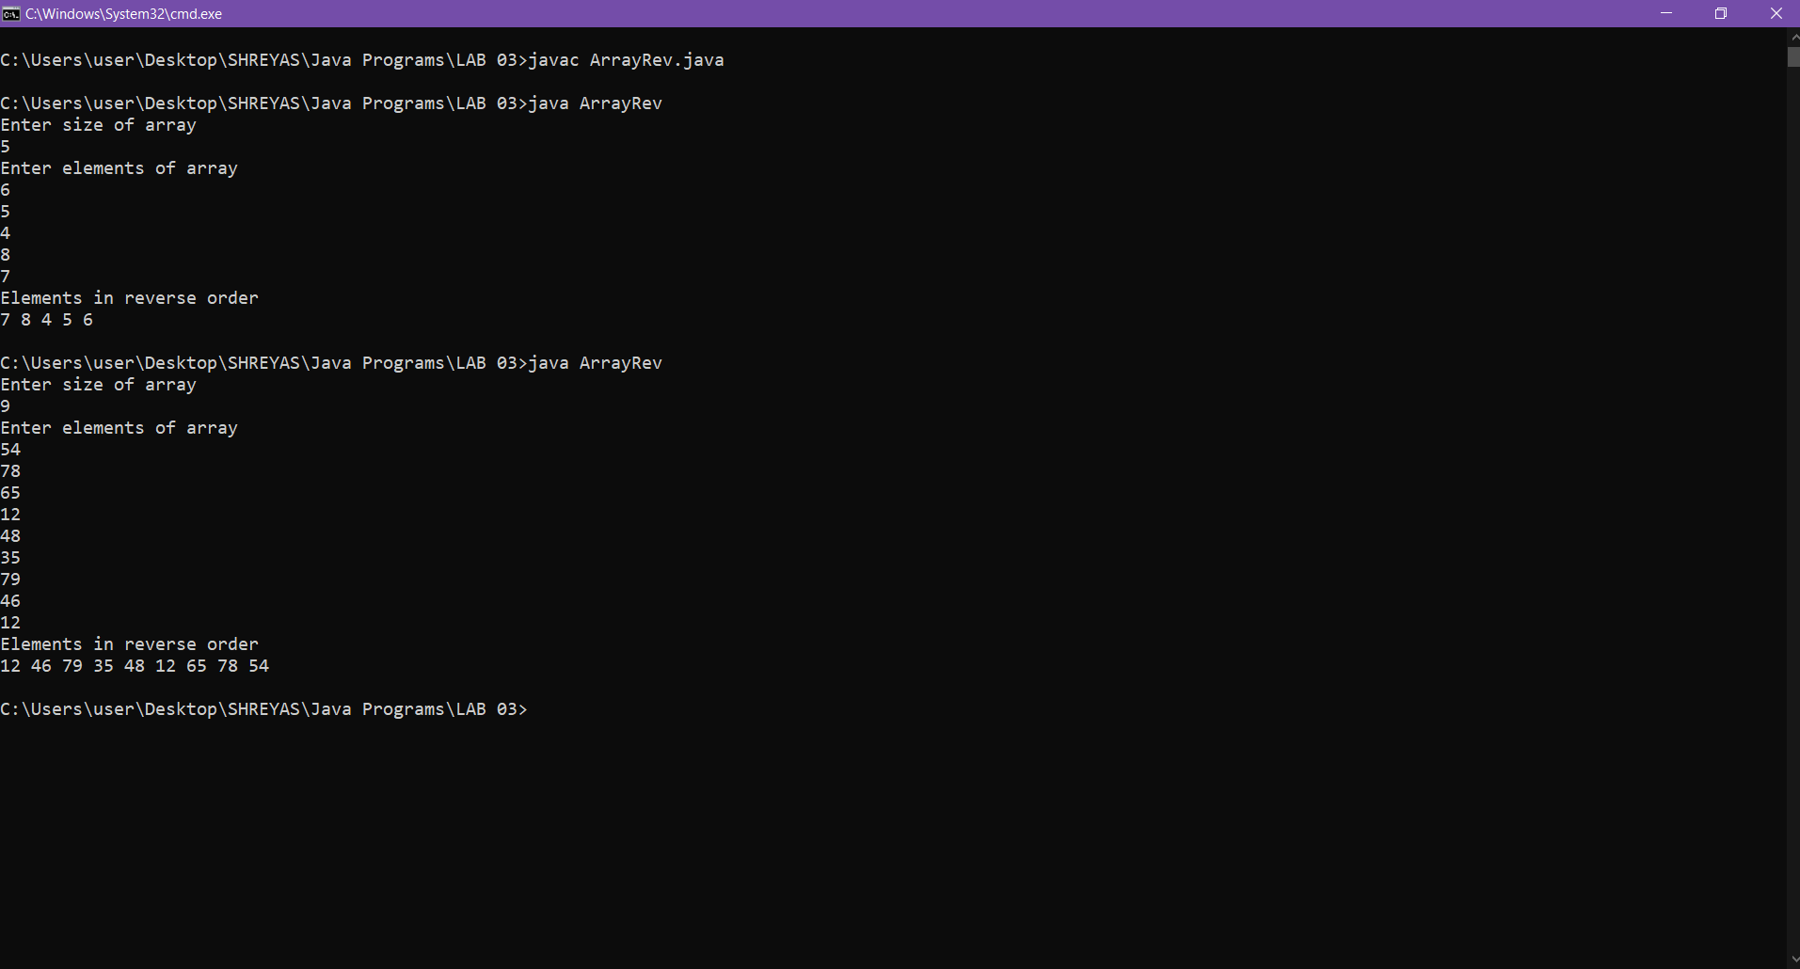

Q.2 Write a program to print the sum of the elements in an array of length n.

CODE:

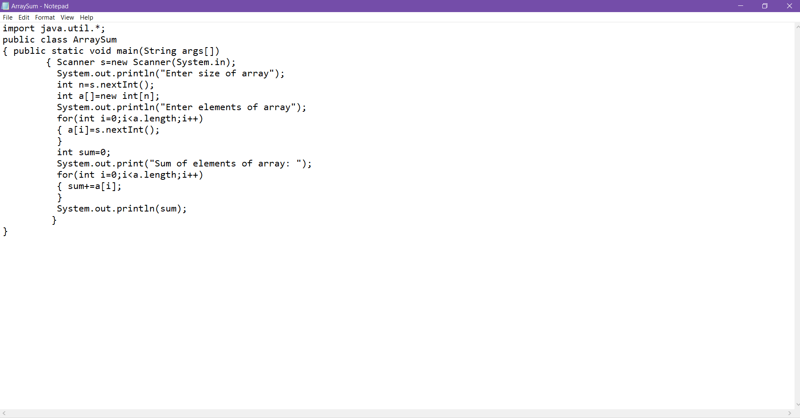

OUTPUT:

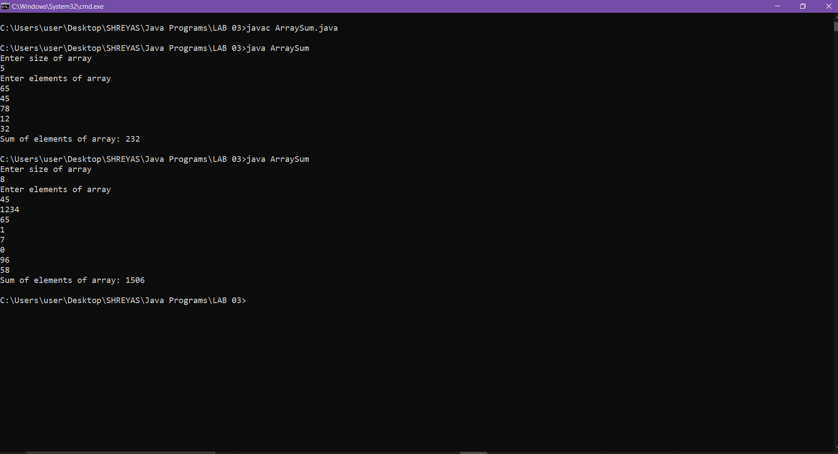

Q.3 Write a program to search an element entered by the user in an array.

CODE:

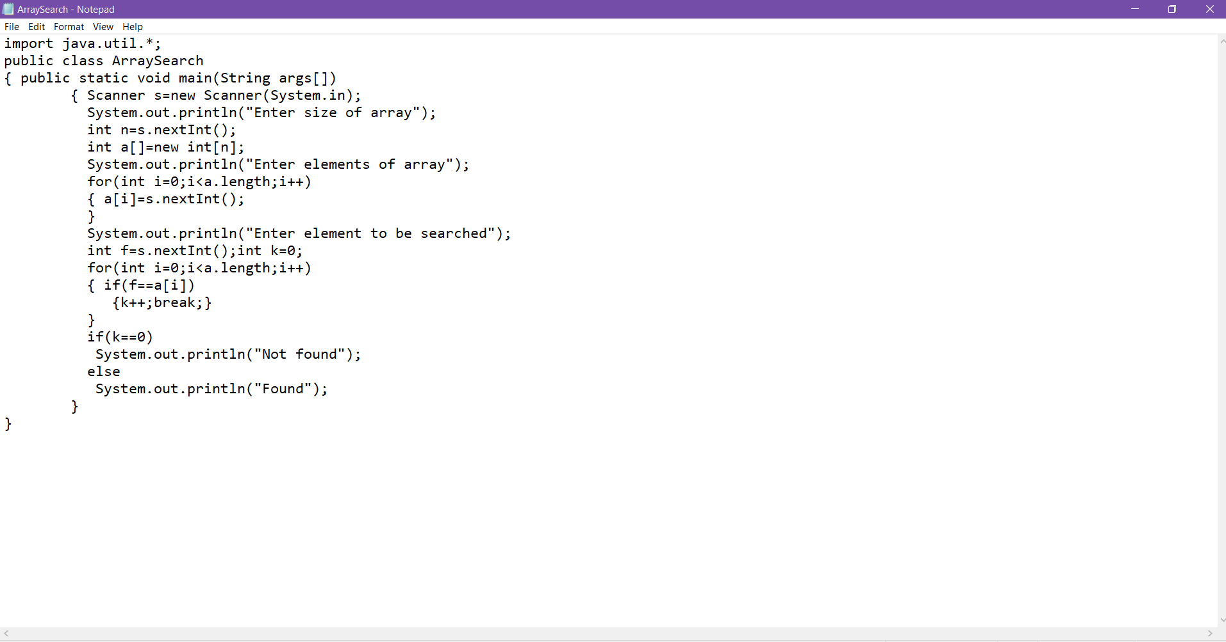

OUTPUT:

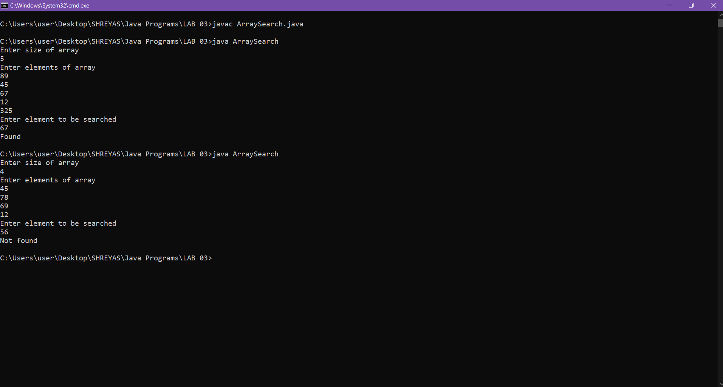

Q.4 Write a program to find duplicates in a given array

CODE:

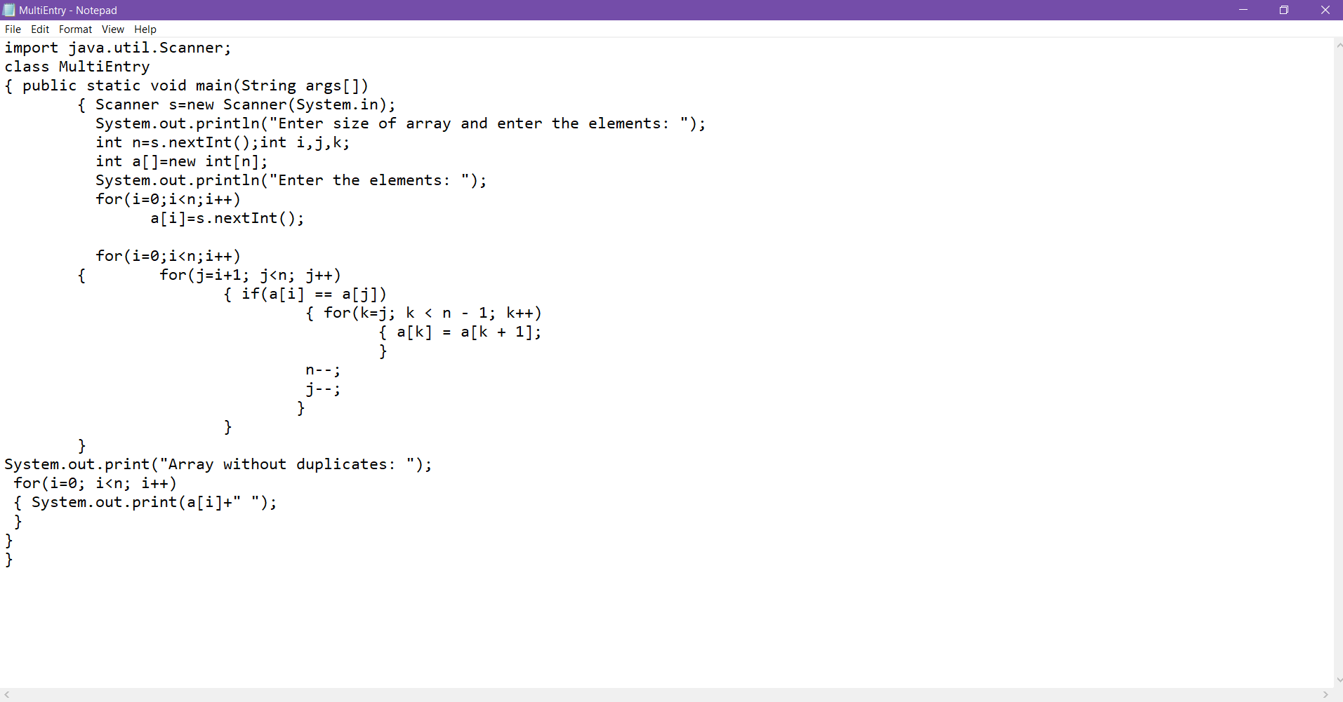

OUTPUT:

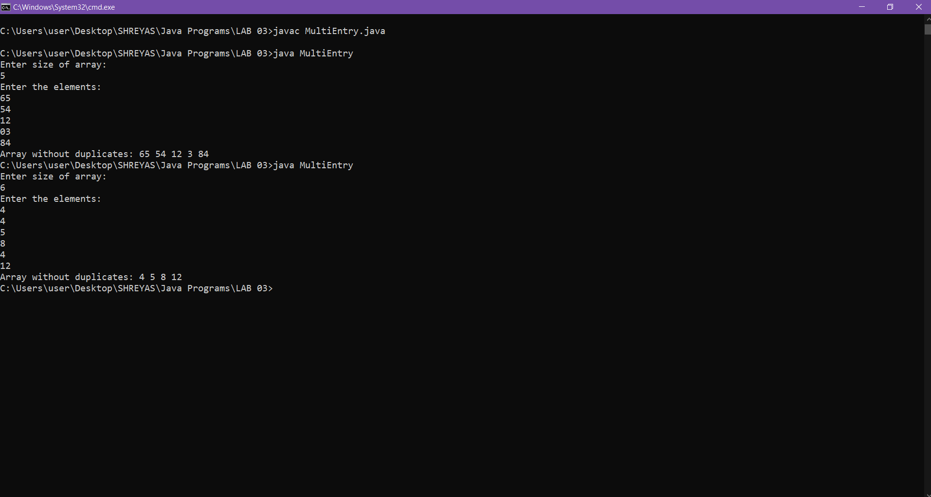

2-D Array

Q.1 Write a program to perform Matrix addition and subtraction   
CODE:

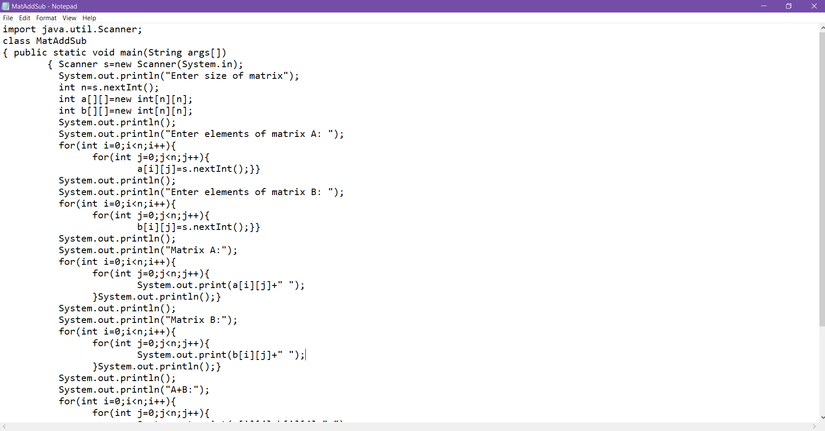

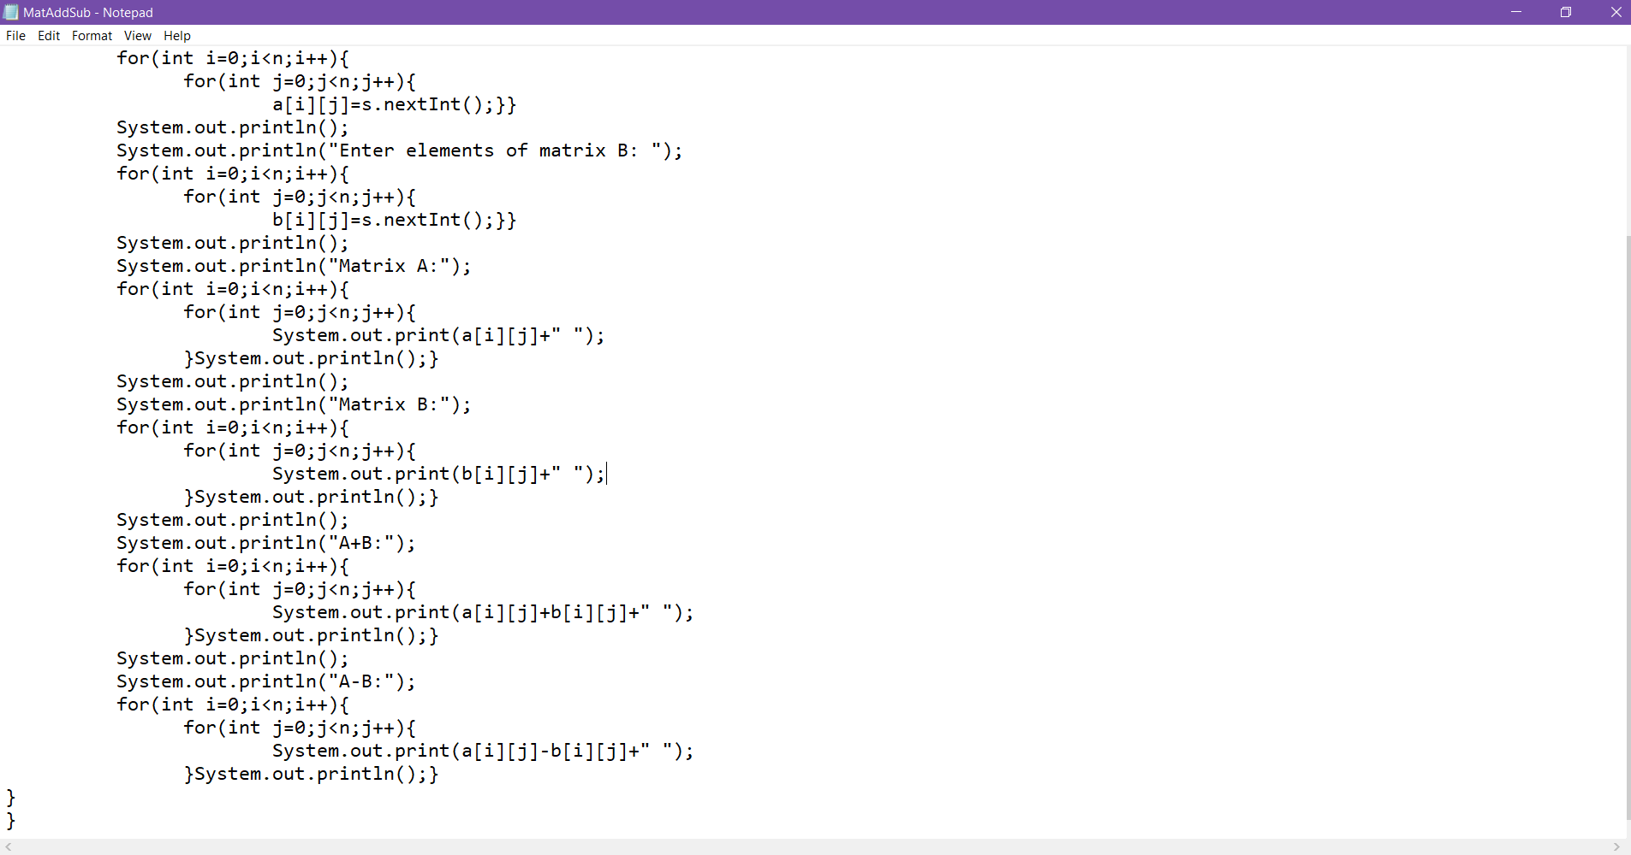

OUTPUT:  
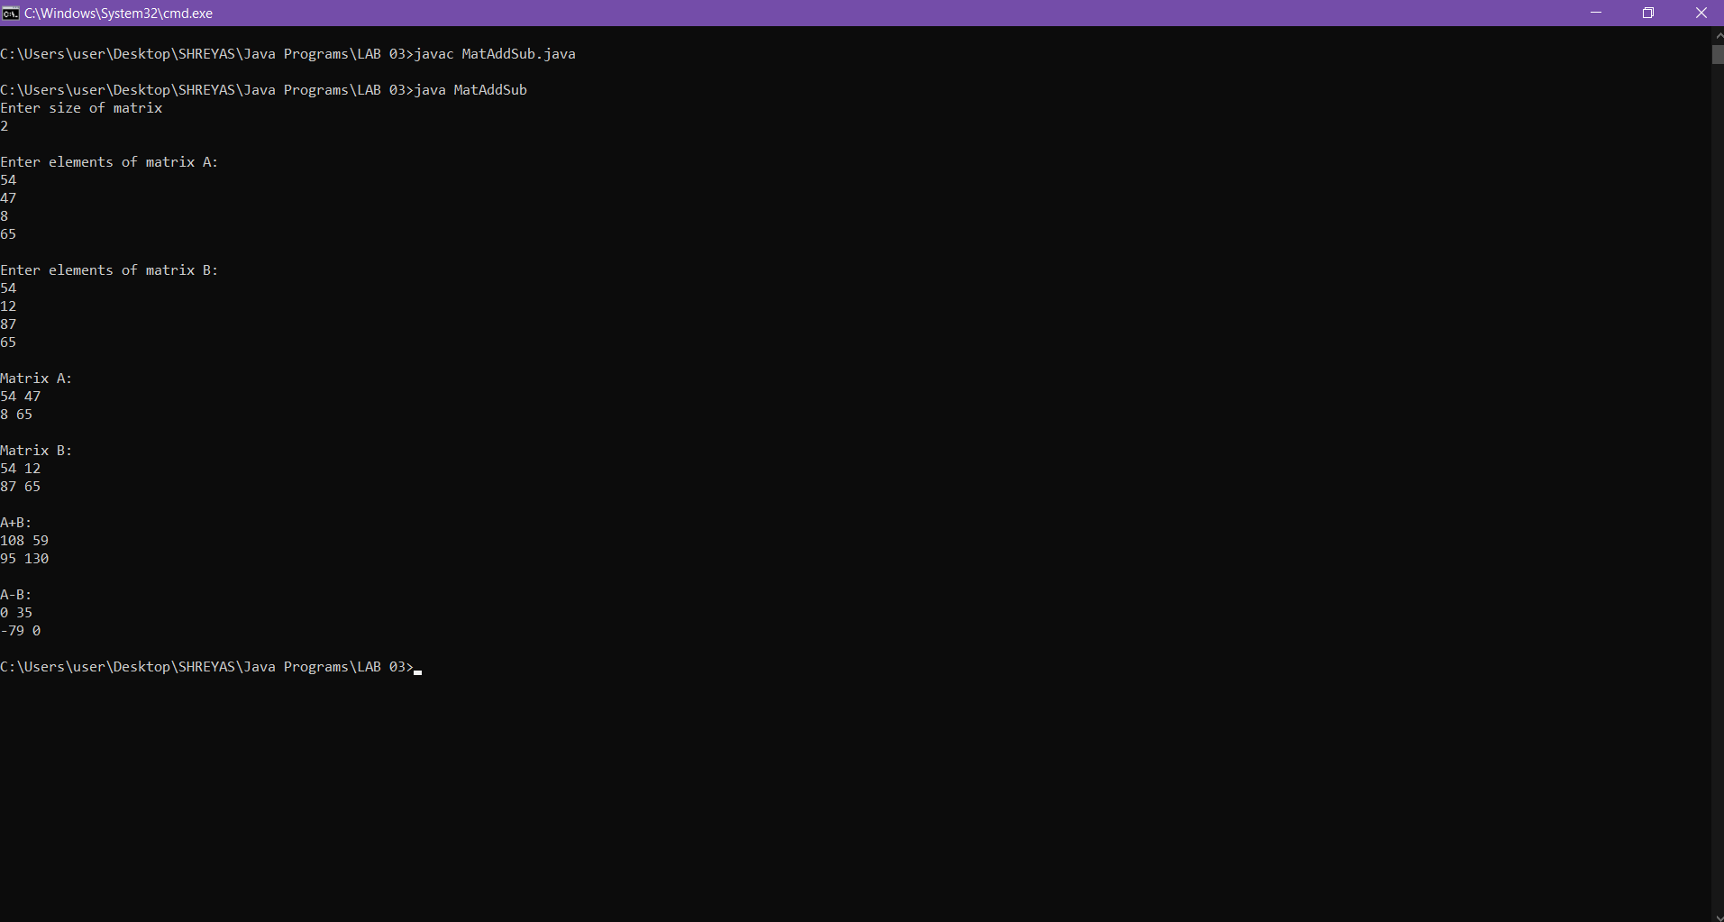

Q.2. Write a program to perform Matrix multiplication  
CODE:

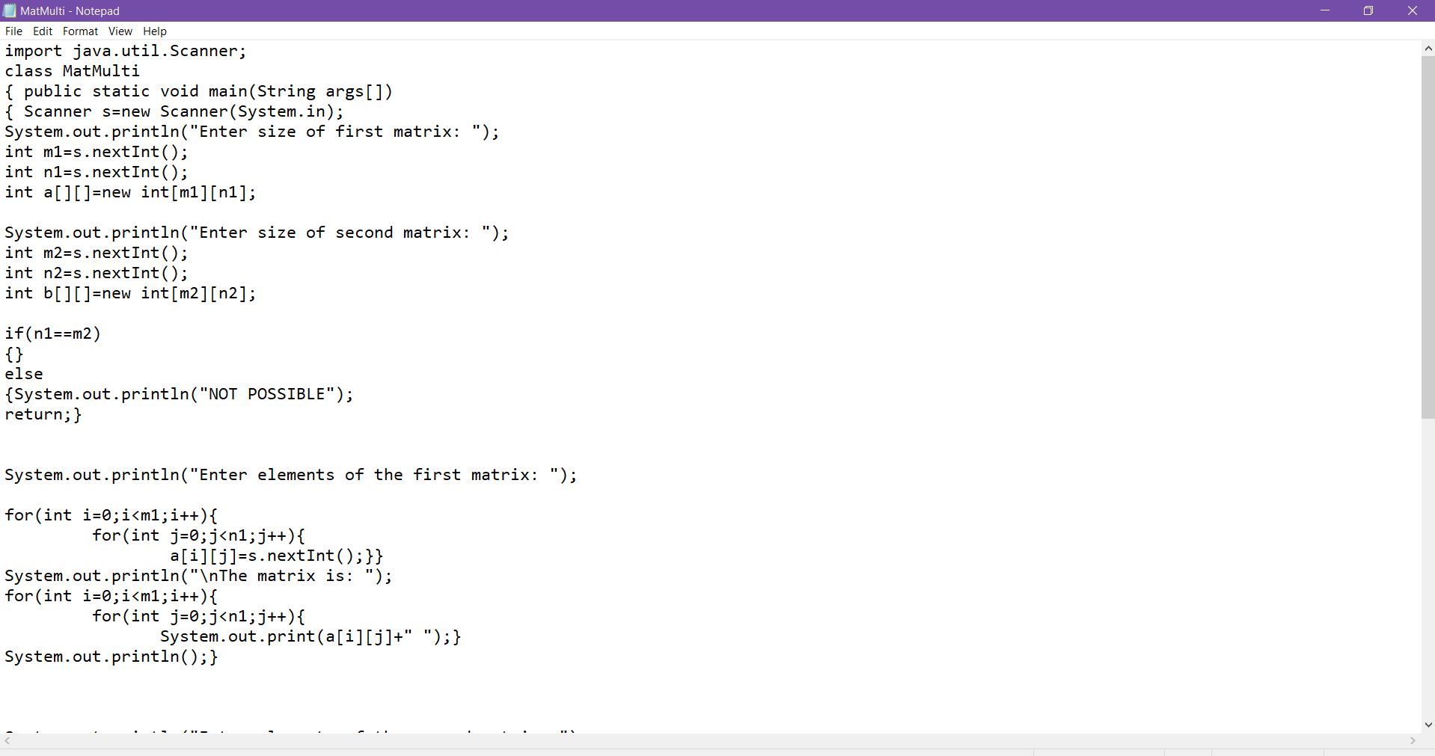

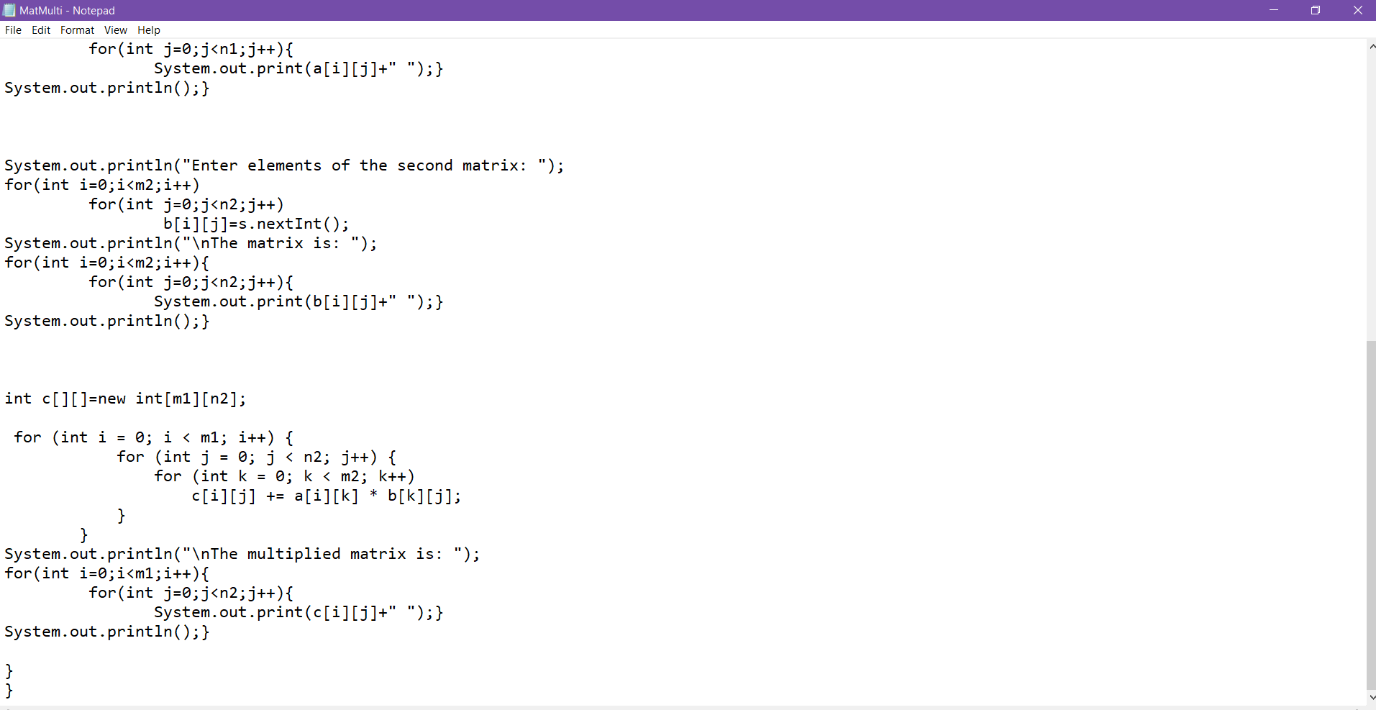

OUTPUT:

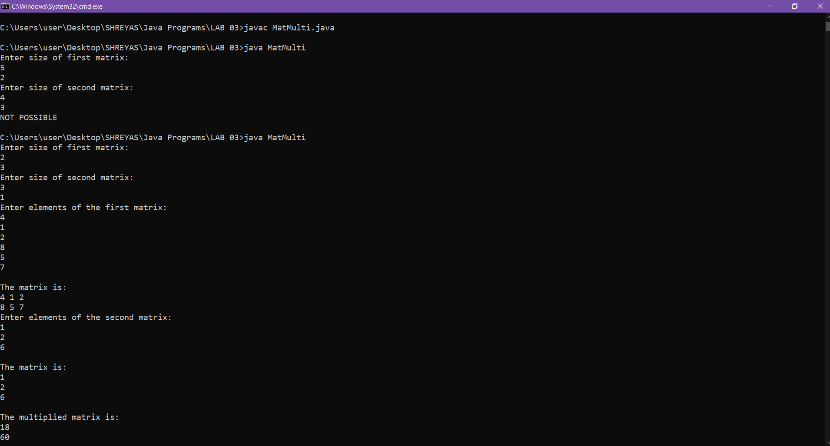

Q.3. Write a program to check if the given Matrix is symmetric or not  
CODE:

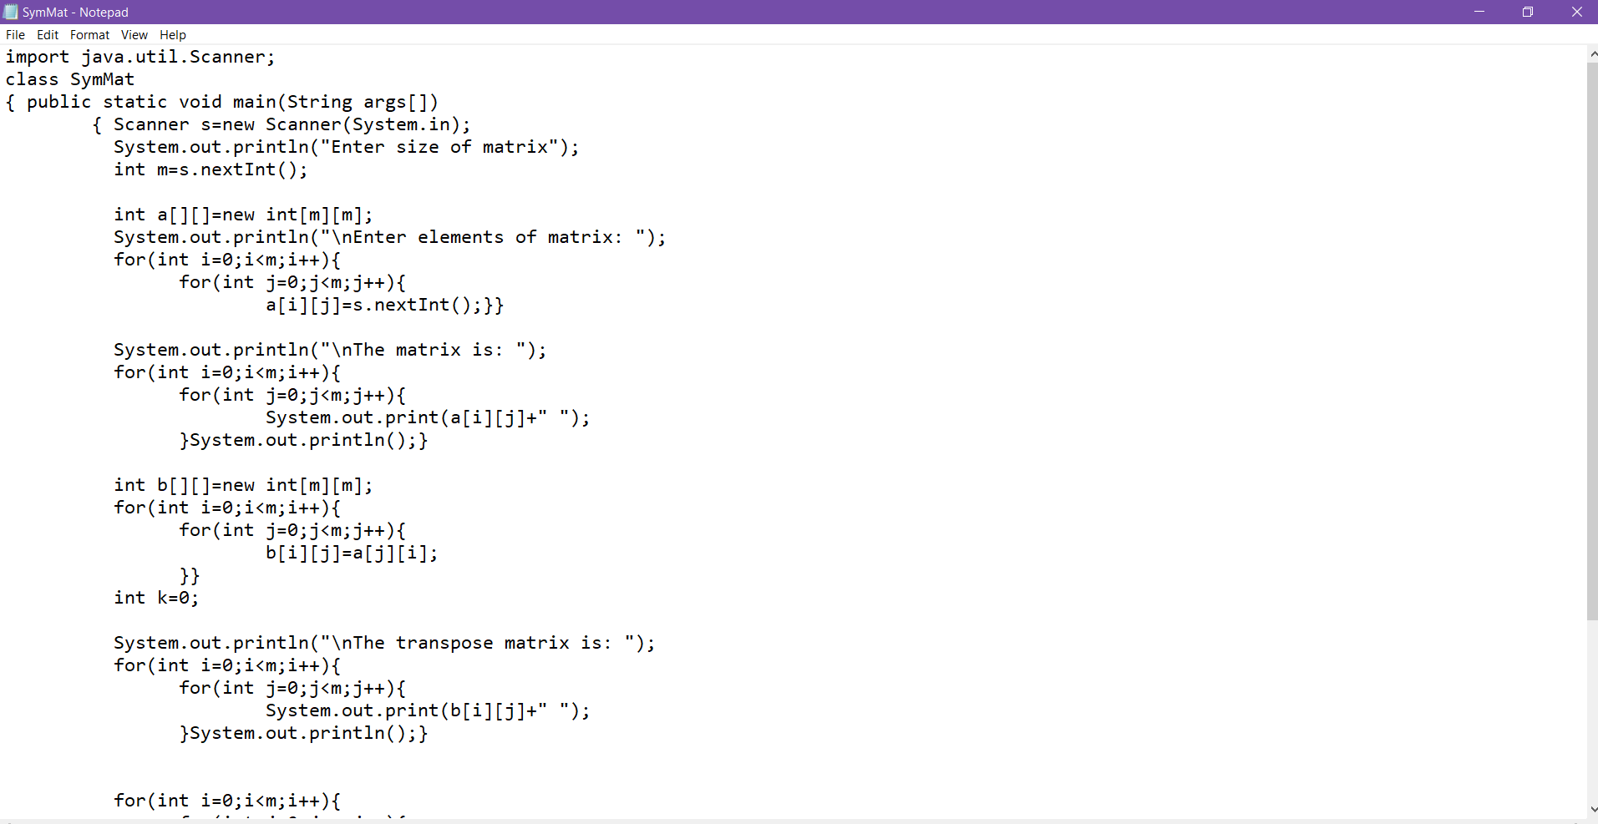

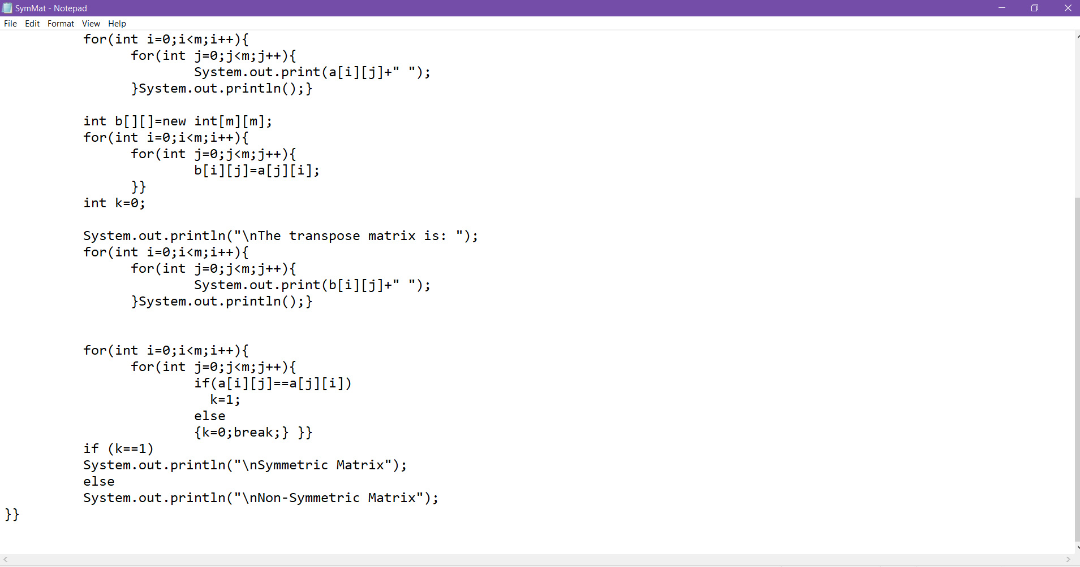

OUTPUT:

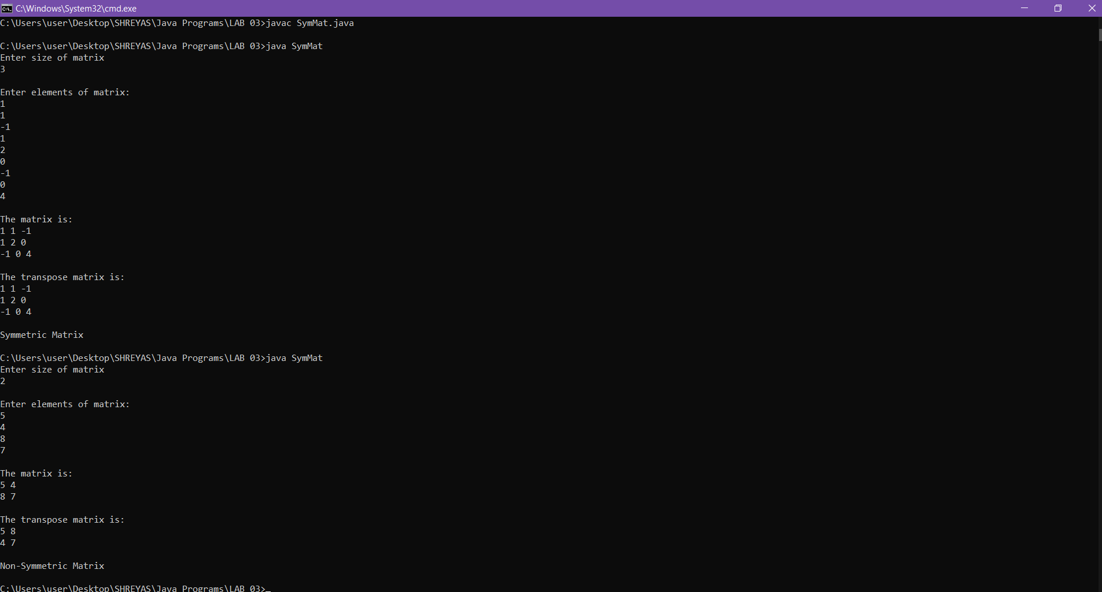

Q.4. Write a program to find the transpose of a given Matrix

CODE:

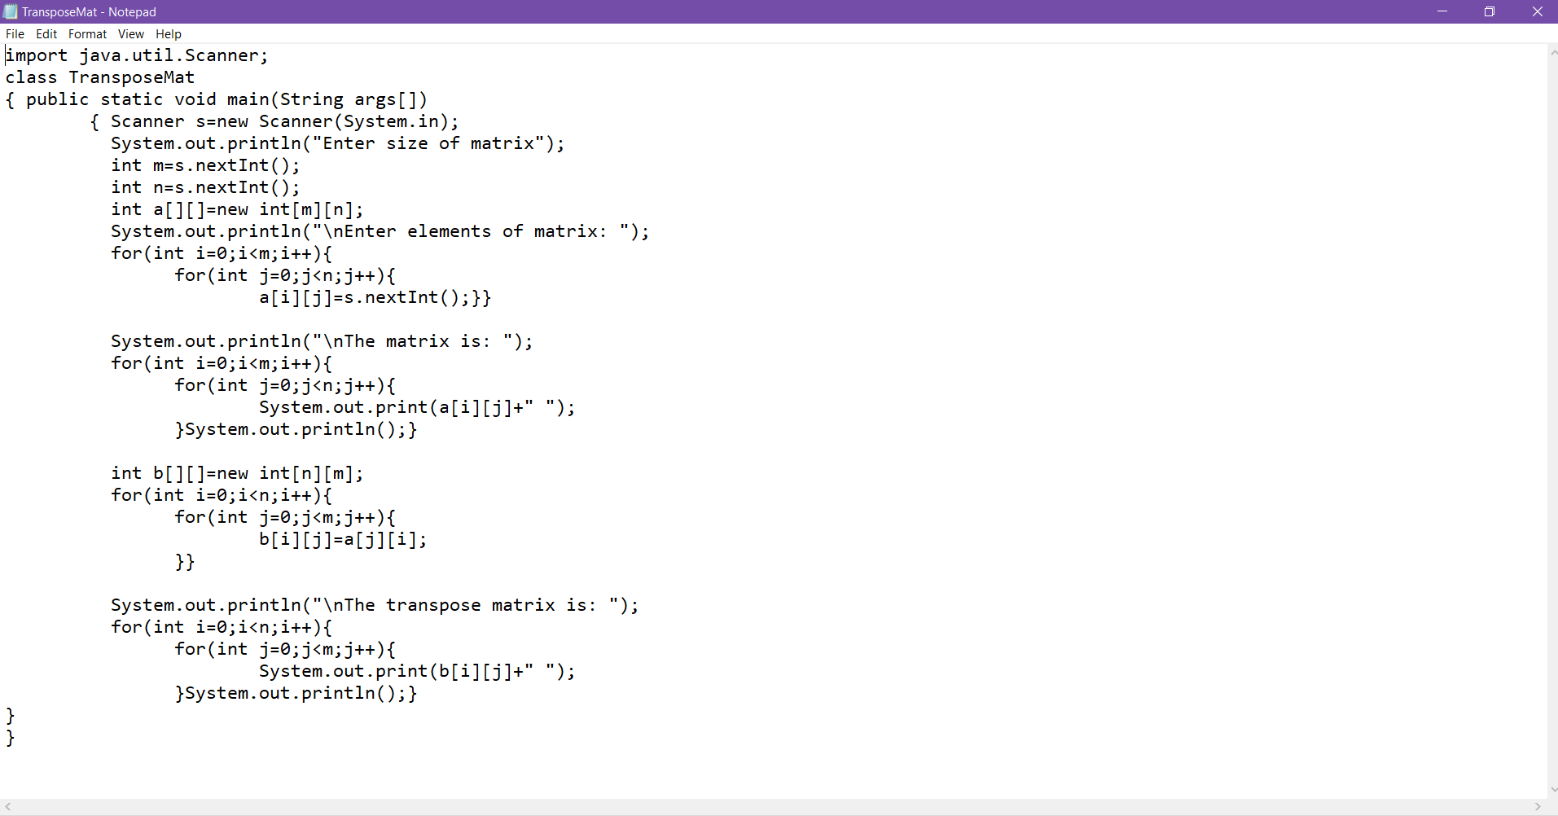

OUTPUT:

